**Capstone Project**

**Problem Statement**

You have been Hired Sr. DevOps Engineer in Abode Software. They want to implement DevOps Lifecycle in their company. You have been asked to implement this lifecycle as fast as possible. Abode Software is a product-based company, their product is available on this GitHub link.

https://github.com/hshar/website.git

Following are the specifications of the lifecycle:

1. Install the necessary software on the machines using a configuration management tool.

2. Git Workflow has to be implemented

3. Code Build should automatically be triggered once commit is made to master branch or develop branch.

- If commit is made to master branch, test and push to prod

- If commit is made to develop branch, just test the product, do not push to prod

4.The code should be containerized with the help of a Dockerfile. The Dockerfile should be built every time there is a push to Git-Hub. Use the following pre-built container for your application:

- hshar/webapp

The code should reside in '/var/www/html'

5. The above tasks should be defined in a Jenkins Pipeline, with the following jobs:

Job1: build

Job2: test

Job3: prod

**Solution Approach**

**Step 1: Create and Setup ec2 instances**

* We will create 3 ec2 instances: 1 Master, 2 Slave nodes for prod and test
* We will set up the connections such that we can ssh from the Master into all Slave nodes

**Step 2: Setting up Master-Slave architecture for ansible**

Used the following set of codes to set up master slave architecture between the Master and 2 Slaves

1. which python3 # check if python is installed

2.

3. # Install Ansible only in the master node

4. sudo yum install -y ansible

5.

6. # Create a new user with the name "ansible" in the MASTER node

7. sudo useradd ansible

8. sudo passwd ansible # Generate a password for the user

9. su – ansible # log in to the user

10.

11. # Create a new user with the name "ansible" in the both slave nodes

12. sudo useradd ansible

13. sudo passwd ansible # Generate a password for the user

14. su - ansible

15.

16. # Provide sudo access to the ansible user in the both the slave nodes

17. cd /etc/ # go to folder

18. sudo vi sudoers # open sudoers in a text editor

19. # add this to wheel: ansible ALL=(ALL) NOPASSWD: ALL

20.

21. # Generate a public and private key in the MASTER node

22. su - ansible # log in to the user

23. ssh-keygen # command to generate keypairs

24.

25. # In order to establish the ssh connection, we need the public IP of the Slave nodes

26. curl ifconfig.me

27.

28. # Run this in SLAVE node to enable ssh port

29. cd /etc/ssh # go to ssh folder

30. sudo vi sshd_config # the file sshd_config has details that needs to be changed

31. # Search for the setting "PasswordAuthentication" and change the setting from "no" to "yes"

32. sudo systemctl restart sshd # restart sshd service

33.

34. # Now try gaining remote access to both servers from Master

35. ssh ansible@13.235.79.77 # Slave 1

36. ssh ansible@52.66.239.74 # Slave 2

37.

38. # Copy public key from master to remote server

39. ssh-copy-id ansible@{slave public ip}

**Step 3: Creating all ansible setup file**

1. Creating the configuration file as follows:

1. [defaults]

2. inventory = /etc/ansible/hosts.ini

3. become = True

4. become_method = sudo

5. become_user = root

6. fork = 5

7. timeout = 30

1. Creating the hosts.ini file as follows:

1. [slave]

2. 13.235.79.77

3. 52.66.239.74

1. Creating the ansible playbooks
   1. The first notebook will install Java and Jenkins in the master node

---

- name: Install Jenkins on AWS Linux EC2 Master Instance

hosts: localhost

become: yes

tasks:

- name: Update all packages

yum:

name: "*"

state: latest

- name: Install Java (required by Jenkins)

command: sudo dnf install java-17-amazon-corretto -y

- name: Download Jenkins repository

get_url:

url: https://pkg.jenkins.io/redhat-stable/jenkins.repo

dest: /etc/yum.repos.d/jenkins.repo

mode: '0644'

- name: Import Jenkins GPG key

rpm_key:

state: present

key: https://pkg.jenkins.io/redhat-stable/jenkins.io-2023.key

- name: Check for package upgrades

yum:

name: "*"

state: latest

- name: Install Jenkins

yum:

name: jenkins

state: present

- name: Start Jenkins service

service:

name: jenkins

state: started

enabled: true

3.2 The second notebook will install Java, Git and Docker on both the slave nodes

---

- name: Install Jenkins on AWS Linux EC2 Master Instance

hosts: slave

become: yes

tasks:

- name: Update all packages

yum:

name: "*"

state: latest

- name: Install Java 17 Amazon Corretto

command: sudo dnf install java-17-amazon-corretto -y

- name: Install Docker

yum:

name: docker

state: present

- name: Start and enable Docker service

systemd:

name: docker

state: started

enabled: true

- name: Install Git

yum:

name: git

state: present

**Step 4: Executing the Ansible Playbook**

The ansible playbook was executed using the below commands:

1. ansible-playbook playbook_master.yml --syntax-check   # code to check for syntax error

2. ansible-playbook playbook_master.yml --check          # dry run on terminal

3. ansible-playbook playbook_master.yml                  # final run on the server

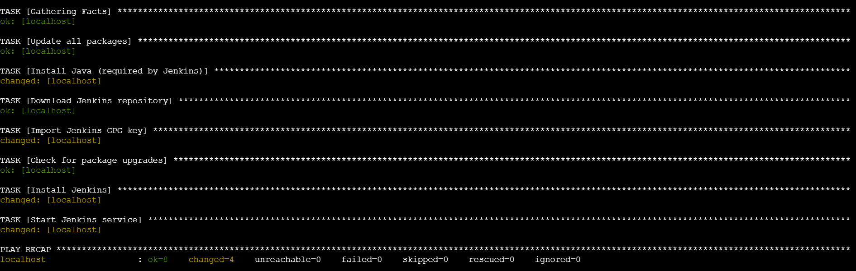

1. ansible-playbook playbook_slave.yml --syntax-check   # code to check for syntax error

2. ansible-playbook playbook_slave.yml --check          # dry run on terminal

3. ansible-playbook playbook_slave.yml                  # final run on the server

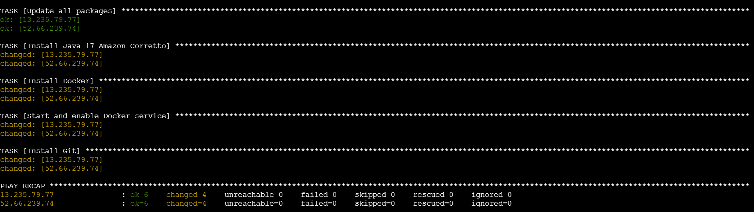

**Step 5: Connect to Jenkins and set up Nodes**

1. Setting up the *test-server* node:
   * Name: *test-server*
   * Number of executors: *1*
   * Remote root directory: */home/ec2-user/jenkins/*
   * Labels: *test*
   * Usage: *Use this node as much as possible*
   * Launch Method: *Launch agents via SSH*
     + Host: *172.31.7.92 (Jenkins test private IP)*
     + Credentials: *ec2-user*
     + Host key verification strategy: *Non verifying*
   * Availability: *Keep this agent online as much as possible*
2. Setting up the *prod-server* node:
   * Name: *prod-server*
   * Number of executors: *1*
   * Remote root directory: */home/ec2-user/jenkins/*
   * Labels: *test*
   * Usage: *Use this node as much as possible*
   * Launch Method: *Launch agents via SSH*
     1. Host: *172.31.9.91 (Jenkins prod private IP)*
     2. Credentials: *ec2-user*
     3. Host key verification strategy: *Non verifying*
   * Availability: *Keep this agent online as much as possible*

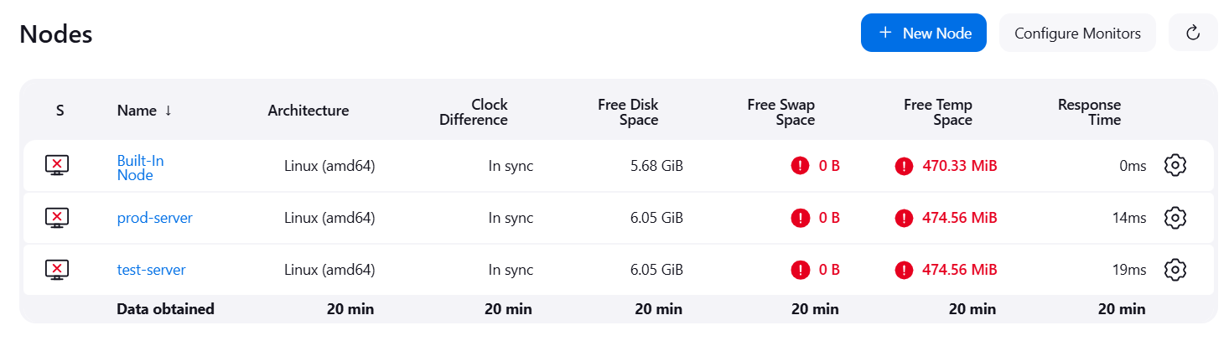

**Step 6: Clone Git Repository, Setup Git Workflow, Create Dockerfile**

Clone the GitHub repository provided in the problem statement. Create a new Dockerfile as shown below and push the file to Github

*Dockerfile*

FROM ubuntu

RUN apt-get update

RUN apt-get install apache2 -y

ADD . /var/www/html/

ENTRYPOINT apachectl -D FOREGROUND

The repository just has a master branch as of now. We also create a *develop* branch as well that will be used for testing purposes

All these changes are then pushed back to GitHub.

**Step 7: Create Jobs on Jenkins and set-up GitHub Webhook**

1. Setting up the *Job 1*:
   * Create new item as freestyle project: *push-to-test*
   * Description: *Trigger build and push to test server when change made in develop*
   * GitHub project: <https://github.com/vyombhatt/website.git>
   * Restrict where the project is run: *test-server*
   * Source code management
     1. Repository URL: <https://github.com/vyombhatt/website.git>
     2. Credentials: *creds not needed as repo is public*
     3. Branch Specifier: *\*/develop*
   * Build Triggers: *GitHub hook trigger for GitScm polling*
   * Build Steps: Execute Shell

*sudo docker rm -f $(sudo docker ps -a -q)*

*sudo docker build . -t job1_docker_image*

*sudo docker run -itd -p 80:80 job1_docker_image*

1. Setting up the *Job2*:
   * Create new item as freestyle project: *push-to-prod*
   * Description: *Trigger build and push to test server when change made in master*
   * GitHub project: <https://github.com/vyombhatt/website.git>
   * Restrict where the project is run: *test-server*
   * Source code management
     1. Repository URL: <https://github.com/vyombhatt/website.git>
     2. Credentials: *creds not needed as repo is public*
     3. Branch Specifier: *\*/master*
   * Build Triggers: *GitHub hook trigger for GitScm polling*
   * Build Steps: Execute Shell

*sudo docker rm -f $(sudo docker ps -a -q)*

*sudo docker build . -t job1_docker_image*

*sudo docker run -itd -p 80:80 job1_docker_image*

1. Setting up the *Job3*:
   * Create new item as freestyle project: *push-to-prod*
   * Description: *Trigger build and push to prod server when change made in master*
   * GitHub project: <https://github.com/vyombhatt/website.git>
   * Restrict where the project is run: *prod-server*
   * Source code management
     1. Repository URL: <https://github.com/vyombhatt/website.git>
     2. Credentials: *creds not needed as repo is public*
     3. Branch Specifier: *\*/master*
   * Build Triggers: *GitHub hook trigger for GitScm polling*
   * Build Steps: Execute Shell

*sudo docker rm -f $(sudo docker ps -a -q)*

*sudo docker build . -t job1_docker_image*

*sudo docker run -itd -p 80:80 job1_docker_image*

Creating Webhook on GitHub:

* Payload URL: <http://13.201.222.193:8080/github-webhook/> (http://{jenkins_url}/github-webhook/)
* Content type: application/x-www-form-urlencoded

**Step 8: Test whether the Jobs get triggered on making commits to Develop and Master**

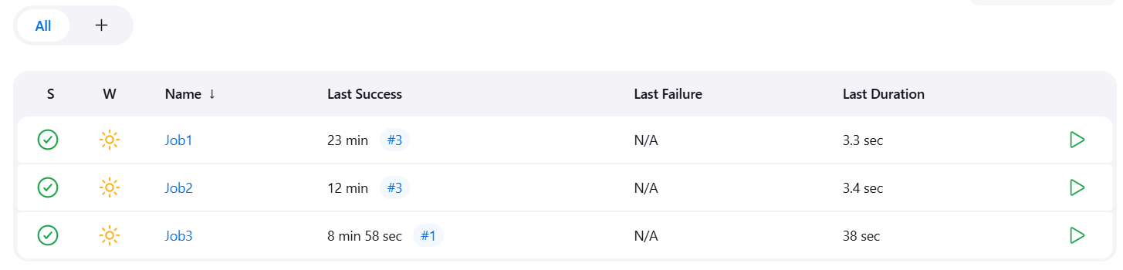

Jobs work fine!